**NAME: 21F-9274**

**Section: BCS-6E**

**TASK 1**

<!DOCTYPE html>

<html lang="en">

<head>

    <meta charset="UTF-8">

    <meta name="viewport" content="width=device-width, initial-scale=1.0">

    <title>INTRODUCTION</title>

</head>

<body>

    <center><H1>NAME : Zain ul Waqas</H1></center>

    <H1>ROLL NO : 21F-9274</H1>

    <H1>ABOUT ME : </H1>

    <P>MY NAME IS Zain. I AM A COMPUTER SCIENCE STUDENT CURRENTLY IN MY SIXTH SMESTER IN FAST NUCES. MY INTERESTS ARE ARTIFICIAL

        INTELLEGENCE AND DATA SCIENCE.

    </P>

</body>

</html>

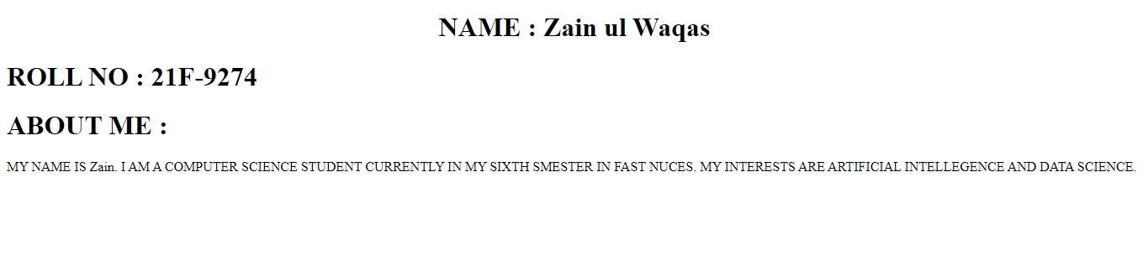

**TASK 2**

<!DOCTYPE html>

<html lang="en">

<head>

    <meta charset="UTF-8">

    <meta name="viewport" content="width=device-width, initial-scale=1.0">

    <title>TEXT FORMATTING</title>

</head>

<body>

    <b>THIS TEXT IS BOLD</b><br>

    <strong>This text is strong</strong><br>

    <big>This text is big</big><br>

    <i>This text is italic</i>

    <em>This text is emphasized</em><br>

    This is <sub>subscript</sub>and<sup>superscript</sup>

</body>

</html>

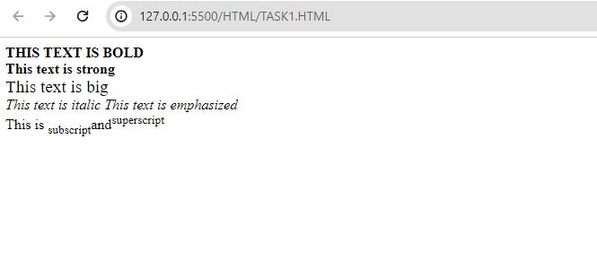

**TASK 3**

<!DOCTYPE html>

<html lang="en">

<head>

    <meta charset="UTF-8">

    <meta name="viewport" content="width=device-width, initial-scale=1.0">

    <title>IMAGE</title>

</head>

<body>

    <img src="logo.png" alt="FAST NUCES logo" height="500" width="500">

</body>

</html>



**TASK 4**

<!DOCTYPE html>

<html lang="en">

<head>

    <meta charset="UTF-8">

    <meta name="viewport" content="width=device-width, initial-scale=1.0">

    <title>IMAGE AS LINK</title>

</head>

<body>

    <a href="https://www.nu.edu.pk/" target="_blank">

        <img src="logo.png" alt="FAST NUCES logo">

    </a>

</body>

</html>





**TASK 5**

<!DOCTYPE html>

<html lang="en">

<head>

    <meta charset="UTF-8">

    <meta name="viewport" content="width=device-width, initial-scale=1.0">

    <title>Document</title>

</head>

<body>

    <h1>Unordered List</h1>

    <p>We have books on a variety of language</p>

    <ul>

    <li>Oracle</li>

    <li>Java</li>

    <li>HTML</li>

    <li>CSS</li>

    </ul>

    <h1>Follow these steps to install Java</h1>

    <ol type="1">

    <li>DOWNLOAD Software</li>

    <li>EXTRACT Folder</li>

    <li>Execute to run</li>

    </ol>

</body>

</html>

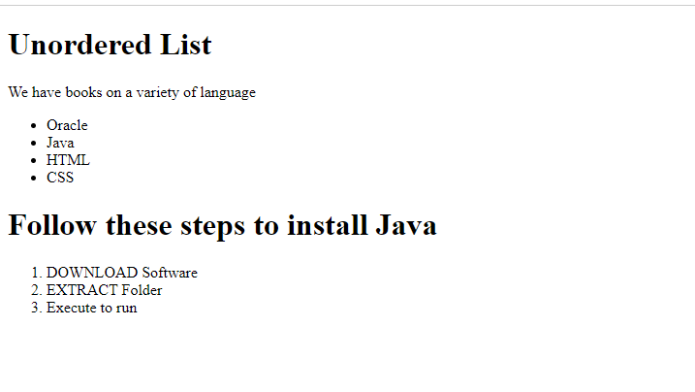

**TASK 6**

<!DOCTYPE html>

<html lang="en">

<head>

    <meta charset="UTF-8">

    <meta name="viewport" content="width=device-width, initial-scale=1.0">

    <title>Document</title>

</head>

<body>

    <table border="1">

        <tr>

            <th rowspan="3">APRIL</th>

            <td>Hello6</td>

            <td>Hello7</td>

        </tr>

        <tr>

            <td>Hello8</td>

            <td>Hello9</td>

        </tr>

        <tr>

            <td>Hello10</td>

            <td>Hello11</td>

        </tr>

        <tr>

            <td>Hello12</td>

            <td>Hello13</td>

            <td>Hello14</td>

        </tr>

    </table>

</body>

</html>

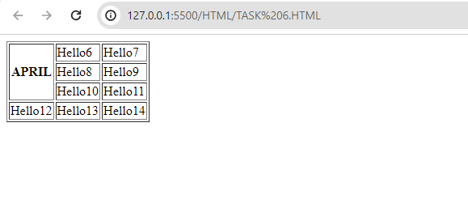

**TASK 7**

<!DOCTYPE html>

<html lang="en">

<head>

    <meta charset="UTF-8">

    <meta name="viewport" content="width=device-width, initial-scale=1.0">

    <title>Document</title>

</head>

<body>

    <table border="1">

        <tr>

            <td>2022</td>

        </tr>

        <tr>

           <th rowspan="2"> <center>FIESTA</center></th>

            <td>Hello6</td>

        </tr>

        <tr>

            <td>Hello8</td>

        </tr>

        <tr>

            <td>Hello10</td>

            <td>Hello11</td>

            <td>Hello15</td>

        </tr>

        <tr>

            <td>Hello12</td>

            <td>Hello13</td>

            <td>Hello14</td>

        </tr>

    </table>

</body>

</html>

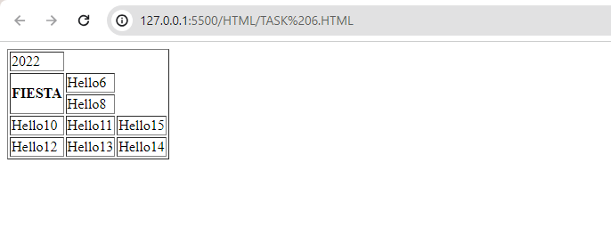

**TASK 8**

<!DOCTYPE html>

<html lang="en">

<head>

    <meta charset="UTF-8">

    <meta name="viewport" content="width=device-width, initial-scale=1.0">

    <title>Document</title>

</head>

<body>

    <h1>SIGN UP FORM</h1>

    <br>

    <form action="backend.php"><br>

    USERNAME:

    <input type="text" ><br><br>

    Email:

    <input type="email"><br><br>

    Password:

    <input type="password"><br><br>

    Confirm Password:

    <input type="password"><br><br>

    <input type="submit" value="submit">

    <input type="reset" value="reset">

    </form>

</body>

</html>

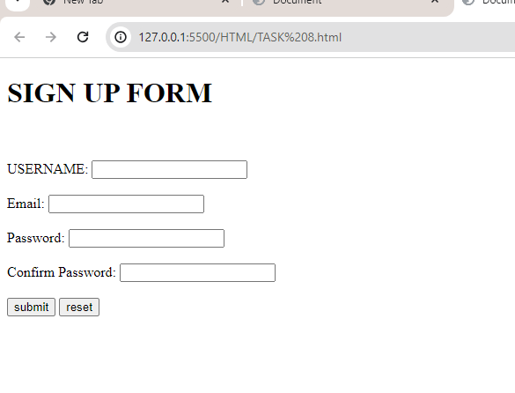

**TASK 9**

<!DOCTYPE html>

<html lang="en">

<head>

<meta charset="UTF-8">

<meta name="viewport" content="width=device-width, initial-scale=1.0">

<title>Pete's Pizza Delivery Online Order Form</title>

</head>

<body>

<center><h1>Pete's Pizza Delivery</h1></center>

<center><h2>Online Order Form</h2></center>

<form name="petes_pizza_delivery_online_order_form" type="text/html">

<label for="name">*Name:</label>

<input type="text" id="name" name="name" required><br><br>

<label for="tel">*Tel:</label>

<input type="tel" id="tel" name="tel" required><br><br>

<label for="address">*Address:</label>

<input type="text" id="address" name="address" required><br><br>

<label for="towncity">*Town/city:</label>

<input type="text" id="towncity" name="towncity" required><br><br>

<label for="postcode">*Postcode:</label>

<input type="text" id="postcode" name="postcode" required><br><br>

<label for="email">*Email:</label>

<input type="email" id="email" name="email" required><br><br>

<p><strong>Required fields</strong></p>

<label for="topping">Topping:</label><br>

<input type="radio" id="margherita" name="topping" value="margherita">

<label for="margherita">Margherita</label><br>

<input type="radio" id="meat_feast" name="topping" value="meat_feast">

<label for="meat_feast">Meat Feast</label><br>

<input type="radio" id="four_seasons" name="topping" value="four_seasons">

<label for="four_seasons">Four Seasons</label><br><br>

<label for="size">Size:</label><br>

<input type="radio" id="small" name="size" value="small">

<label for="small">Small</label><br>

<input type="radio" id="medium" name="size" value="medium">

<label for="medium">Medium</label><br>

<input type="radio" id="large" name="size" value="large">

<label for="large">Large</label><br><br>

<label for="extras">Extras:</label><br>

<input type="checkbox" id="mushrooms" name="extras" value="mushrooms">

<label for="mushrooms">Mushrooms</label><br>

<input type="checkbox" id="green_peppers" name="extras" value="green_peppers">

<label for="green_peppers">Green peppers</label><br>

<input type="checkbox" id="anchovies" name="extras" value="anchovies">

<label for="anchovies">Anchovies</label><br>

<input type="checkbox" id="extra_cheese" name="extras" value="extra_cheese">

<label for="extra_cheese">Extra cheese</label><br><br>

<label for="preferred_delivery_time">Preferred delivery time:</label>

<input type="time" id="preferred_delivery_time" name="preferred_delivery_time"><br><br>

<label for="delivery_instructions">Delivery instructions:</label><br>

<textarea id="delivery_instructions" name="delivery_instructions" rows="4" cols="50"></textarea><br><br>

<input type="submit" value="Submit order">

</form>

</body>

</html>

